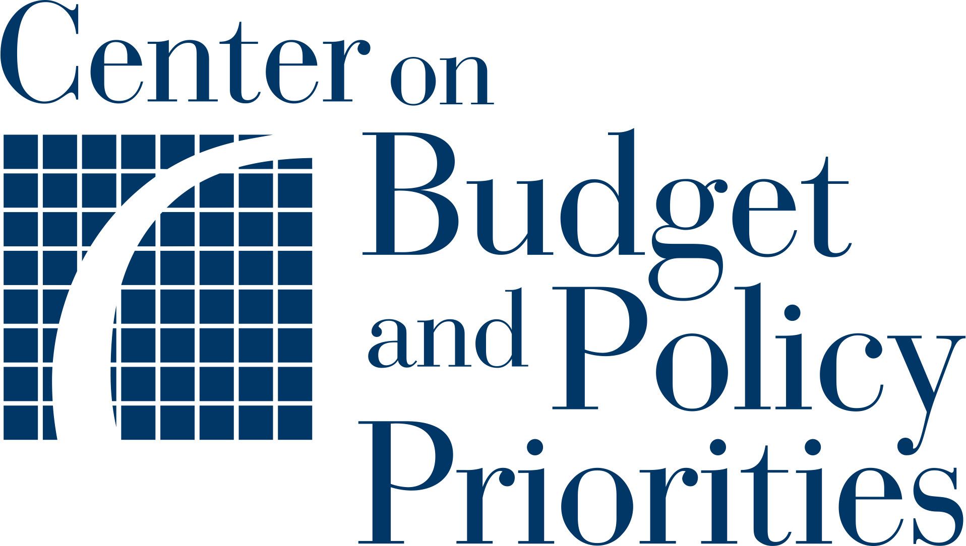
Planning Tool 8:
Developing an Engagement Plan

Fill out this engagement plan template to map out the content, order, and frequency of outreach messages for a two-way text outreach project. Each box should contain a message, and boxes in the same chain should represent a series of texts, including responses to inquiries from the recipient. Aim to use a clear, concise message for each step. It may be helpful to invite team members who work on communications to complete this tool with your team.

Project Name:
Message Number:
Tip: 1-2 SMS per message is recommended
- 1 SMS character limit is 160
- 2 SMS character limit is 306

Initial Outreach Text Message

1
3
Replies
2

Project Name:
Message Number:

Follow-up Text Message 1

1
2
Replies

Project Name:
Message Number:

Follow-up Text Message 2

1
3
Replies
2

Project Name:
Message Number:

Follow-up Text Message 3

1
2
Replies

