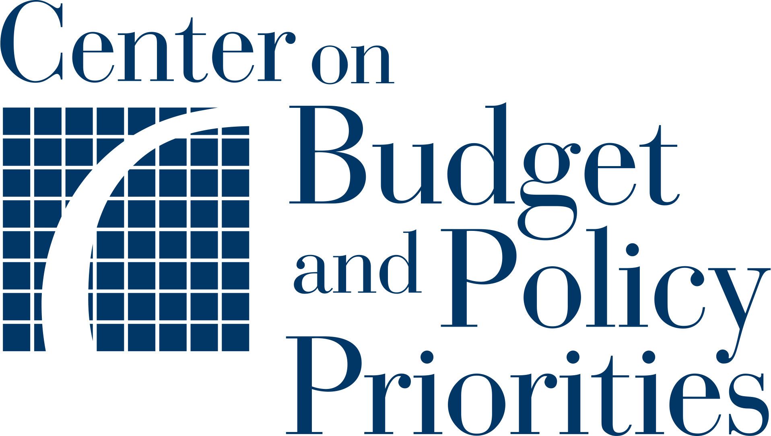Planning Tool 7:

**Developing Messaging1**

|  |  |
| --- | --- |
|  | Purpose  This exercise is designed to help you plan the content of your outreach messages, whether sent via mail, phone, or text. The following considerations for crafting messages reflect experience in recent text outreach pilots as well as established research. Review the messaging considerations laid out here and in the related guide, and brainstorm how they may apply to your project in the space provided.  **IMPORTANT**    Review the guide from ideas42, [Using Behavioral Science to Improve the WIC Experience](https://www.cbpp.org/sites/default/files/cbpp_bdt_wic_toolkit_applying_behavioral_science_to_improve_WIC_outreach_messaging.pdf) for an overview of key concepts that can help inform your messaging. Insights from behavioral science suggest practical strategies that can improve the effectiveness of communications and motivate people to take the actions requested of them. |

|  |  |
| --- | --- |
|  | Key Considerations   * It is valuable to engage current WIC participants and eligible non-participants when crafting outreach messages. Their guidance and feedback can help ensure that the messages you develop will resonate with your audience. * While similar concepts regarding language, word choice, and messaging apply regardless of outreach method, there are important differences to keep in mind for each. Brevity is more important for texting than for other forms of outreach, whereas in paper-based methods (letters, postcards, flyers, ads, etc.), it is essential to consider the visual design and flow of information. For these methods, compelling graphics and illustrations can heighten the impact of outreach. * When identifying the next step an outreach recipient will be asked to take — referred to as the call to action — the form of the outreach matters. For example, while clicking a link is an easy call to action from text-based or email-based outreach, getting to a website from paper-based outreach can be challenging, especially if typing out a website address is required. |

____________________

This planning tool was developed by Allison Yates-Berg with ideas42, <https://www.ideas42.org/>.

**1. Preparing to Design Communications**

The framing of an outreach message can affect whether it is read and understood and whether the recipient takes the action requested of them. Before applying behavioral science strategies to design communications, it’s critical to answer questions related to whom you are trying to reach, what you are asking the recipient to do, and how you are planning to deliver the message. The answers to these questions will guide how you deploy different behaviorally informed strategies in your messaging.

|  |  |  |
| --- | --- | --- |
| **Question** | **Example Answer** | **Your Answer** |
| Who is your target audience? | ***Ex. 1 (General):*** *All WIC-eligible families not currently enrolled*  ***Ex. 2 (Specific):*** *Pregnant individuals newly enrolled in Medicaid* |  |
| What action are you asking them to take? | *Reply “1” to request an appointment*  ***Tip:*** *Keep the ask as simple and short as possible!* |  |
| What barriers may prevent the recipient from taking that action? | *Preparing paperwork or documents* |  |
| How do you plan to deliver the message(s)? | *A series of text messages* |  |

**2. Applying Behavioral Science Best Practices for Designing for Chronic Scarcity**

When designing outreach for WIC, it is important to keep in mind that participants often lack vital resources such as time, food, and money. Outreach messaging is more likely to be effective if it makes the action feel manageable (through use of short and simple language) and engages participants in a dignity-affirming manner. Drawing from ideas42’s Poverty Interrupted work, best practices may include:

1. **Cutting the costs:**

Cut the cognitive costs of understanding and acting on messaging by:

* Using short, clear, and actionable language in the text message and avoiding jargon.
* Making it easy for participants to take the action you’re asking them to take by automating processes and outlining clear action steps.

**How can you apply the principle “cut the costs” in your messages?**

***Example:*** *Provide a link to a form to provide information and upload documents. (****TIP****: Keep messages as short and simple as possible.)*

|  |
| --- |
|  |

1. **Creating slack:**

Add “slack” through messaging to ensure participants aren’t totally derailed in the event something gets in the way of a particular action. This can include:

* Providing options for accessible and responsive help, for example by including a phone number to call.
* Acknowledging that issues may arise, such as the need to reschedule appointments, and offering options and flexibility, such as allowing participants to attend an appointment with incomplete paperwork (depending on your state’s rules).
* Sending multiple, timely reminder text messages (but not too many).

**How can you apply the principle “create slack” in your messages? Think about the barriers you listed in Question 1.**

***Examples:*** *Send a reminder one week before an appointment and the day before an appointment.*

|  |
| --- |
|  |

1. **Reframing and empowering:**

Ensure that messages promote dignity by:

* Using welcoming language that avoids reinforcing harmful stereotypes of WIC participants.
* Using the language(s) of the WIC participants you’re serving, and considering accessibility needs for those who may be hearing or vision impaired.
* Treating families as experts when creating communications, such as by adding them to your team or asking for their feedback on communications.

**How can you apply the principle “reframe and empower” in your messages?**

***Example:*** *Avoid stern warnings about fraud and emphasize the positive ways families benefit from WIC.*

|  |
| --- |
|  |

**3. Inspiring Recipients to Take the Actions Requested of Them**

There are many behaviorally informed communications strategies that may motivate or encourage a recipient to take a particular action. Two important strategies that have a considerable evidence base in research by ideas42, in public benefits programs and beyond, are highlighting benefits and costs and incorporating a salient deadline when appropriate.

1. **Emphasizing the costs of inaction (and the benefits of action):**

Communications should make clear the implications of action or inaction. Making those costs and benefits stand out in a communication is helpful for motivating behavior.

**How might you emphasize costs of inaction and/or benefits of action in your messaging?**

***Example:*** *Don’t miss out on breastfeeding support for you and your baby!*

|  |
| --- |
|  |

1. **Making any deadlines as salient as possible:**

When recipients need to complete an action such as fill out a form or submit paperwork by a certain date, it is helpful to make those deadlines stand out clearly in the communication. Deadlines need to be carefully thought about and messaged appropriately.

**How do you plan to make any deadlines in your communications salient to recipients of your communications (if appropriate)?**

***Example:*** *Please upload any documents by Thursday, September 30th at 5 p.m.*

|  |
| --- |
|  |

**4. Testing Messages: How Do You Know Your Messages Are Resonating With Recipients?**

Although many of the tools discussed in this toolkit have an evidence base, testing your messages will give your team valuable insight to ensure that outreach resonates with your target audience(s).

Depending on your team’s capacity and resources, there are several different types of testing you can pursue:

* **Usability testing** allows you to engage potential recipients in the design of your messaging and get feedback, early and often, from your target audience on your communication materials.
* **A/B testing** allows you to test different versions of a communication to understand which one resonates the most or is the most effective.
* **Pilot testing** allows you to refine your message before it goes out to an entire group or population, or measure the impact of a message on a specific group.
* **Testing while scaling** allows you to use a phased rollout of a new communication over time and location to estimate impacts.

**How will your team conduct message testing?**

***Example:*** *Plan one-on-one usability tests with current WIC participants.*

|  |
| --- |
|  |