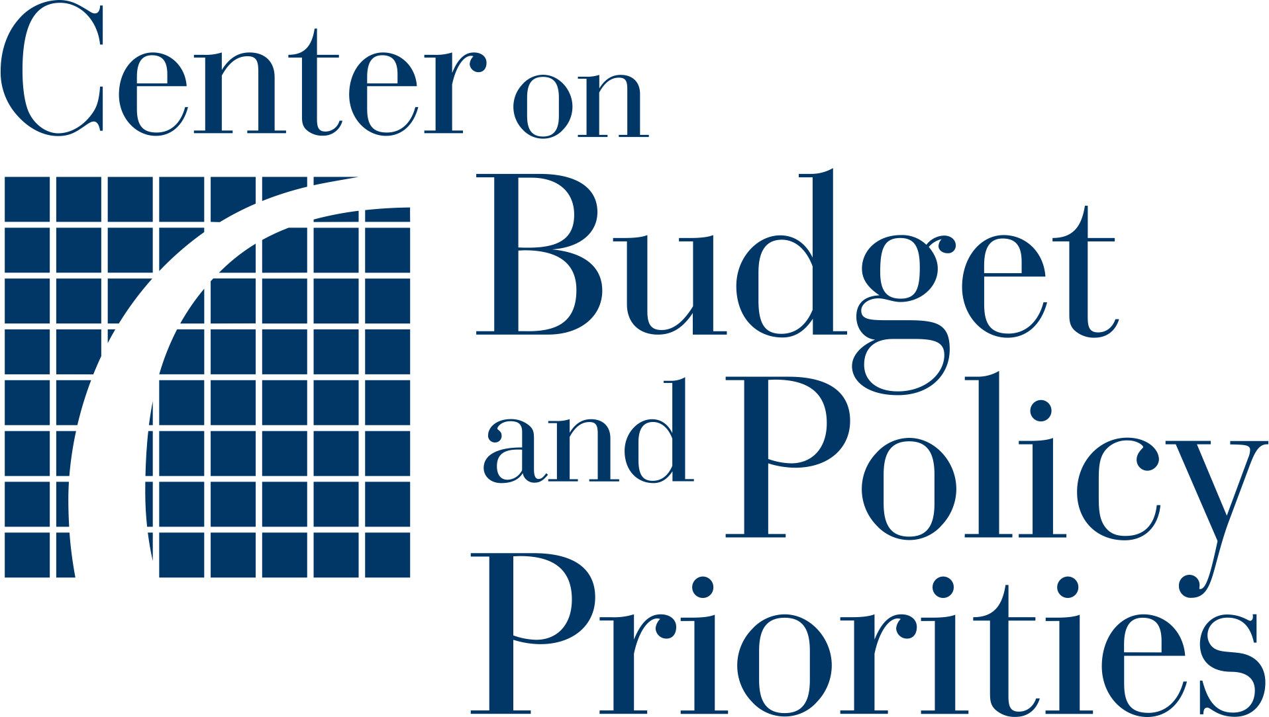Planning Tool 6:

**Planning for Outreach**

|  |  |
| --- | --- |
|  | Purpose  This tool discusses considerations for planning or modifying a targeted outreach initiative, drawing on lessons learned from targeted outreach pilots and ongoing projects in other states. It offers a template for states to document initial steps of planning for outreach, including which methods of outreach will be used, how frequently outreach will be conducted, and metrics to monitor. The initial sections are intended to be general, so your team may use them to plan any type of outreach initiative; the later steps are specific to a text-based strategy. |

|  |  |
| --- | --- |
|  | Instructions  Use steps 1 – 4 to think about whom you are contacting using any kind of outreach strategy. The remainder of the steps will walk you specifically through planning a text-based outreach strategy, since this is a newer method for contacting families and states may be less familiar with best practices. While completing each step, review the considerations described below and draft plans for incorporating these considerations into your outreach project where prompted. |

**1. Target Audience**

First, consider your target audience. Individuals participating in Medicaid, SNAP, or the Temporary Assistance for Needy Families (TANF) cash assistance program, and children in foster care could be included, depending on the available data, your ability to avoid contacting families multiple times if they participate in more than one program, and the number of applicants WIC staff can manage. You should also consider whether there are special subgroups within the population you have identified that you specifically hope to reach.

**What people or groups will you send targeted outreach to?**

***Example:*** *Targeted outreach pilots sent messages to families enrolled in SNAP, Medicaid, TANF, or foster care but not enrolled in WIC.*

|  |
| --- |
|  |

**2. Outreach Method**

Next, you will want to decide how you will contact families. The method you choose may vary based on the average age of the people you are trying to reach or where they live.

**What is the primary method you will use for outreach? Will you use additional methods?**

***Example:*** *We will use text-based outreach for all families with a mobile phone number, and we will send a letter to other families.*

|  |
| --- |
|  |

**3. Frequency of Contact**

Next, consider how often you will contact families. This includes planning follow-ups for families whom you have already contacted as well as planning when to reach out to new families.

If outreach is going to be conducted regularly, it is important to decide how often to contact the same family if they do not respond or enroll in WIC after an outreach communication is sent. (An outreach communication might include a series of text messages.) To avoid repeatedly contacting a family that may not be interested in WIC, a state could remove from the outreach group anyone who received outreach recently — in the last six months, for example. Another strategy is to match WIC data only against individuals who enrolled in Medicaid or SNAP after the last data matching and outreach was conducted.

Your team may also need to segment outreach groups if the number of individuals who might respond to the outreach would be too large for your staff to handle. Many states will segment lists and contact families in batches, in addition to planning a series of follow-up messages, calls, or letters, all of which will affect the overall outreach plan.

|  |  |  |
| --- | --- | --- |
| **Question** | **Example Answer** | **Your Answer** |
| How many families will you contact at a time? | *We will divide the outreach group into four segments consisting of X number of families.* |  |
| How many attempts will you make to reach individuals? If you are using multiple types of outreach (e.g., mail, phone, text), how many attempts will you make per outreach method and how will you sequence them? | *We will make up to four attempts to contact individuals via text.\** |  |
| How frequent will the outreach attempts be? | *Attempts will occur one week apart.* |  |
| When will you resume contacting a family that has already received outreach based on an earlier match? | *We will remove from future outreach any individual who received outreach in the previous six months.* |  |

* In the initial states that partnered with BDT and CBPP to [pilot](https://www.cbpp.org/research/food-assistance/using-data-matching-and-targeted-outreach-to-enroll-families-with-young) WIC data matching and targeted text outreach strategies, states generally sent four texts to reach nonparticipants. While each new outreach attempt generated some new responses, engagement tapered off with each subsequent message and very few individuals responded by the fourth attempt. If states conducting data matching and outreach monitor and share their results, they can help other states learn more about the best approach to the number and pace of outreach messages.

**4. Language**

If data on participants’ preferred written or primary language are available, it will be helpful to include this information in the data match so that you can consider how you might deliver outreach messages in families’ preferred languages. If this is not possible, there may be alternative ways of providing language access services to reach these families more effectively. For example, the message could include a link to information in multiple languages on a website or offer a phone number to connect callers to translation services.

When drafting your messages, it is also important to consider the language in which the message will be sent. A message written in English may not have the same connotations or brevity when translated. It would be beneficial to designate a skilled individual to participate in drafting and reviewing all translated messages, such as a professional translator fluent in each language in which the outreach will be sent.

|  |  |
| --- | --- |
| **Question** | **Your Answer** |
| In what language will you send outreach? |  |
| How will you determine which languages to use? |  |
| Will you provide translation services? If so, how? |  |

|  |  |
| --- | --- |
|  | The rest of this tool specifically focuses on text-based outreach. Because texting may be a newer outreach method for state and local WIC agencies, this toolkit provides additional information to help you plan a texting campaign based on promising practices. Teams that are weighing different outreach methods may find it helpful to consult [Considerations for Different Outreach Media](https://bdtrust.org/cbpp-bdt-wic-texting-guide.pdf#page=9), which compares key aspects of mail, phone, and text outreach. |

**5. Who Will Send the Texts?**

An early step in planning text outreach is deciding who will be responsible for sending the texts. Multiple arrangements may be feasible depending on existing infrastructure and capacity, and each option may have its own advantages. Use the space below to consider each option and choose which works best for your state.

|  |  |  |
| --- | --- | --- |
| **Potential Approach** | **General Considerations** | **Considerations for Your State** |
| The state WIC agency sends text outreach messages. | There are several advantages to the state agency deploying outreach. First, some WIC agencies already have statewide texting capabilities and only need to import a list of contact information generated through the data match to launch outreach. In addition, this approach enables uniformity across the state, which promotes equity and makes it more feasible to evaluate the outreach campaign. Lastly, this arrangement may be more sustainable than approaches that rely on parties outside of WIC.[1] |  |
| Local WIC agencies send text outreach messages. | In some cases, local WIC agencies already use texting as a regular form of communication with WIC participants. It may be possible to adapt these processes to include targeted text outreach to non-participants identified through a data match. |  |
| A partner agency, such as the state agency administering Medicaid or SNAP, sends text outreach messages about WIC. | The agency administering Medicaid, SNAP, or another means-tested program might have greater capacity to deploy text outreach. In addition, recipients might be more comfortable receiving a text message from a program they are already participating in. One potential disadvantage of this approach is that it could limit the extent of the WIC agency’s input in the details of the outreach, such as message content, number of messages, and timelines. |  |
| A third-party contractor sends text outreach messages for WIC. | This approach has similar advantages to the state WIC agency deploying outreach in terms of uniformity, equity, and evaluation. It also offers an option that can be employed by states that do not yet have statewide texting capacity. In addition, this approach may be easier to implement if a state is interested in testing a new approach but is hindered by staff availability or competing priorities. Under this arrangement, it is important to note that data-sharing agreements must be written to include the third-party contractor. Depending on the third party’s relationship to the state WIC agency, this approach could be less sustainable than having a state agency send the text messages.[2] |  |

**6. Messenger**

In addition to deciding who will actually send the texts, you will need to determine in advance who the texts will appear to come from — the messenger. The messenger does not necessarily need to be the person or organization physically sending the texts. For example, texts could be identified as coming from WIC or from the Medicaid or SNAP agency, even if deployed by a third-party vendor.

Key considerations for identifying the messenger include:

* **Using an individual’s name:** Some outreach campaigns associate a staff person’s name with text outreach; for example, a text may read “Hi! This is Dorothy from WIC.” This helps to establish credibility and trust with the text outreach recipient and a personable tone.
* **Choosing a trusted messenger:** Your team will need to consider what you know about the group that will receive outreach and whom that group already knows and trusts. This information is key to choosing an appropriate and trusted messenger. For example, if the outreach group is already enrolled in SNAP but not WIC, then having the SNAP agency serve as the messenger may establish greater trust with that group.
* **Determining a phone number:** There are several options to consider when determining the phone number that texts are deployed from, including “short codes” (a five- or six-digit number), “long codes” (a normal ten-digit phone number), and toll-free numbers (generally 800-numbers that are ten-digit “long codes”). Each option has advantages and disadvantages. For example, a long code allows for an area code specific to the state in which the texts are being sent. States exploring these options will need to consider the text platform being used and the type of campaign being designed.

|  |  |  |
| --- | --- | --- |
| **Question** | **Example Answer** | **Your Answer** |
| Who will be identified as the messenger of text outreach messages? | *Because we plan to reach out to a group already enrolled in SNAP, the texts will say they are from the SNAP agency (which families are already familiar with).* |  |
| What phone number will texts come from? | *Texts will be sent from long-code, toll-free phone numbers.* |  |

**7. Automated vs. Manual Texts**

While automating text outreach requires up-front work — such as programming and testing — over time, an automated process is likely to be more efficient than manual outreach. Sending texts manually allows messaging to be more tailored or personalized but requires much more staff time. Your team should consider the audience and weigh the benefits and drawbacks of each method when making this decision.

**Will texts be automated or sent manually? Why?**

|  |
| --- |
|  |

1. **One-Way vs. Two-Way Texting**

Will outreach recipients be able to respond to the text messages they receive? One-way texting is typically automated and sends a message to the outreach group but does not allow for responses. Two-way texting can also be automated or can take the form of a manual texting exchange. In automated two-way texting, a series of engagements is mapped out, and responses are pre-programmed based on suggested responses to the outreach messages. The capacity of the texting platform being used might determine the approach, but if both options are available, two-way texting offers several advantages. It allows for multiple interactions, might feel more engaging to the recipient, and allows for a wider variety of possible next steps. For example, two-way texting allows for a recipient to request a call to schedule a certification appointment.

**Will you use one-way or two-way texting?**

|  |
| --- |
|  |

**9. Call to Action**

Your texts should include simple, clear instructions – known as the “call to action” – encouraging recipients to do something and letting them know what will happen next. Ideally, if a recipient of a text outreach message expresses interest in enrolling in WIC, a follow-up step would be taken by WIC staff to ensure that the certification process gets underway. This next step could be a call or text from a statewide call center or from a local WIC agency to begin the certification process or schedule a certification appointment.

Alternatively, states that already have an online form to collect basic enrollment information can include a link to this form so that WIC staff can follow up. This may be a simpler process if WIC staff already have mechanisms in place to respond to submissions of online forms. To allow for monitoring the results of the outreach, states can use a distinct link for the form sent via outreach text (rather than sharing the link to the form that is disseminated publicly).

You can use the space below to draft your call to action, as well as to brainstorm the possible follow-up steps when an individual responds to the message.

|  |  |  |
| --- | --- | --- |
| **Call to Action** | **Potential follow-up step**  *(automated)* | **Potential follow-up step**  *(manual)* |
| ***Example:*** *Recipients will be directed to an online form that allows them to request a certification appointment.* | *Recipient receives a follow-up text with a dedicated link to the certification appointment request form.* | *WIC agency staff member responds with a dedicated link to the certification appointment request form and offers to answer any questions or help prepare for an appointment.* |
|  |  |  |
|  |  |  |
|  |  |  |
|  |  |  |
|  |  |  |
|  |  |  |

1. **Monitoring Outreach Engagement and Certification Outcomes**

Determining at the outset what needs to be learned from an outreach campaign can help inform key decisions, such as reporting structures or even text platforms. The ability to track an outreach recipient through certification is key to understanding the effectiveness of outreach, including the points in the process where some interested individuals drop out. You may also want this information when evaluating the program (and can refer back to it when planning your program evaluation later on). Use the space below to think through some of the possible data points and how you will track them.

|  |  |  |
| --- | --- | --- |
| **What metric could**  **you track?** | **Where are data for**  **this metric kept?** | **Who will track**  **this metric?** |
| Number of responses to each text outreach message |  |  |
| Number of outreach recipients who never responded |  |  |
| Number of recipients who opt out of texts |  |  |
| Number of recipients who request a certification appointment |  |  |
| Number of recipients who schedule a certification appointment |  |  |
| Number of recipients who show up for an appointment and get certified |  |  |
| Other: |  |  |
| Other: |  |  |

1. Massachusetts and Montana used this approach for their data matching and targeted outreach pilots and continue to do so today. For more information, see “[Using Data Matching and Targeted Outreach to Enroll Families With Young Children in WIC—Lessons Learned From State Pilots](http://www.cbpp.org/wicpilotreport),” Benefits Data Trust and Center on Budget and Policy Priorities, January 5, 2021.
2. In the Colorado and Virginia pilots, BDT conducted the texting on behalf of the state WIC agencies. For more information, see “[Using Data Matching and Targeted Outreach to Enroll Families With Young Children in WIC—Lessons Learned From State Pilots](http://www.cbpp.org/wicpilotreport),” Benefits Data Trust and Center on Budget and Policy Priorities, January 5, 2021.