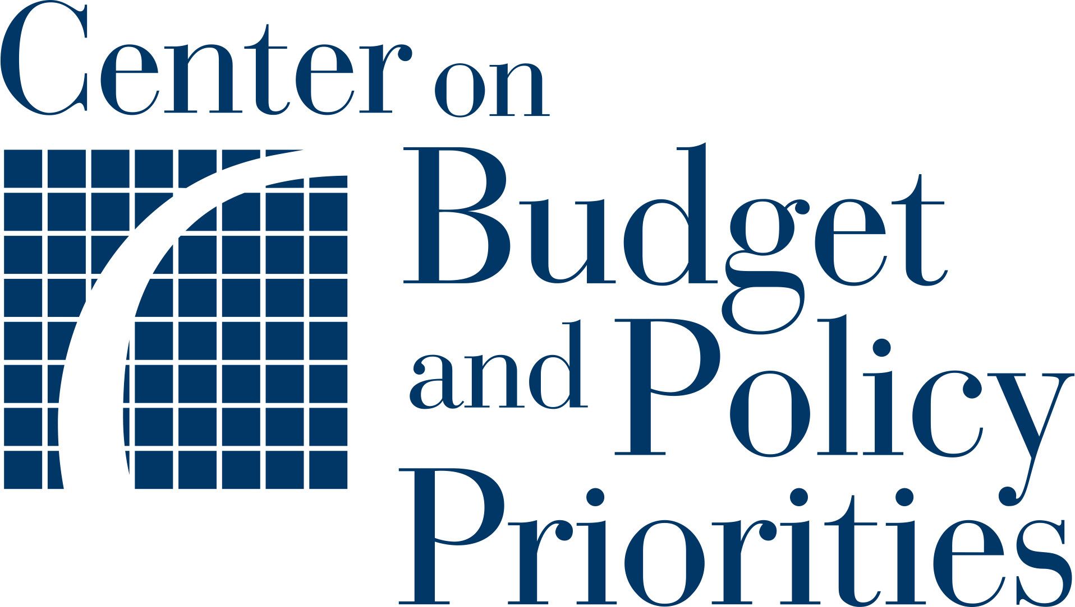Planning Tool 1:

**Describing the Outreach Landscape**

|  |  |
| --- | --- |
|  | Purpose  Before considering new targeted outreach and streamlined certification processes for your WIC program, your team may find it helpful to examine current outreach practices. This will help you avoid redundancies in work and identify areas for opportunity, thereby paving the way for developing strategies that will be effective. Your team members may know this information already, but often it is useful to collect all relevant notes in one place as a starting point for the activities that follow throughout the planning process. |

|  |  |
| --- | --- |
|  | Whom Should You Consult?  Depending on how you complete this step, you may want to have other colleagues review the information to ensure it is as complete and accurate as possible, or you can gather your team and complete the questions together. |

1. **What outreach methods do your state and local agencies currently use?**

This could include conducting text-based outreach, sending letters about eligibility, using social media, making calls, or other methods.

|  |
| --- |
|  |

1. **How are community-based organizations and local nonprofits involved in providing support?**

|  |
| --- |
|  |

1. **Are there certain groups that you know are under-enrolled in WIC? If so, list them below.**

|  |
| --- |
|  |

1. **Is any current outreach targeted to specific groups (certain ZIP codes, ages, races, etc.)? If yes, how?**

|  |
| --- |
|  |

1. **Would you like to initiate new targeted outreach to any under-enrolled groups not currently receiving it? If so, how?**

|  |
| --- |
|  |

1. **What steps are current outreach recipients asked to take to express interest in WIC?**

Select any of the choices below that are relevant and add any that are missing.

|  |
| --- |
| Reply to a text to express interest in WIC enrollment  Click a link to schedule a WIC certification appointment  Click a link to fill out an online pre-application for WIC  Click a link to fill out an online application for WIC  Call a phone number for more information or to schedule a WIC appointment  Download an app that offers WIC certification appointments  Click a link to an online directory to find the nearest WIC clinic location or phone number  Other:  Other:  Other: |

1. **How do state or local agency staff follow up once outreach recipients express interest?**

For example, they could call families to schedule an appointment or schedule an appointment via text, email, or an online form. List all the follow-up methods your state uses.

|  |
| --- |
|  |

1. **When your team has launched previous outreach campaigns, what internal and external stakeholders have been involved? What were their roles and responsibilities in conceptualizing or implementing the outreach activities?**

A list of stakeholders is included below to get you started.

|  |  |
| --- | --- |
| **Stakeholder:**  Agency that administers Medicaid  Agency that administers SNAP  Agency that administers TANF  Legal advisors  Information technology specialists  Data privacy specialists  Research or evaluation experts  Local WIC agencies  Community-based organizations  Nonprofit organizations | **Role:** |

1. **When your team has launched previous outreach campaigns, how did you assess whether they were effective? What data did you collect?**

|  |
| --- |
|  |

1. **Now think about the future. Is anyone who should be involved in launching a new targeted outreach campaign missing from your current list?**

This is an opportunity to build new partnerships to address gaps in prior outreach plans.

|  |
| --- |
|  |