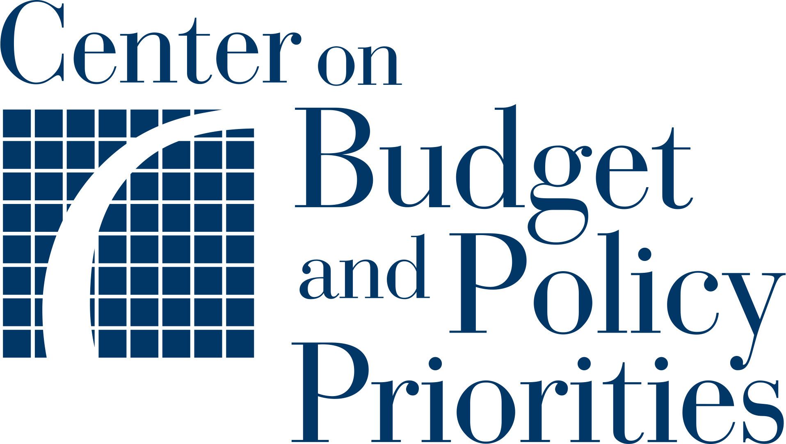
Planning Tool 12:
Implementation Timeline

Use the space below to plan your timeline for the entire scope of your WIC outreach initiative. Begin by adding the steps that are next for your state in the planning process. Review all of the prior tools you have completed and copy all of the key steps that need to occur, and the order in which they need to occur, to ensure a successful outreach initiative. Be sure to include steps related to developing a data sharing agreement, implementing outreach, completing evaluation activities, or any subsequent actions that must be taken.

The steps listed below are examples; please delete, revise, or add to them based on your agency’s approach and timelines. You can add more rows to the table as needed.
Next Steps  List the actions that need to be taken in  order to implement your data matching and targeted text outreach initiative. | Who is responsible?  List the name and title of the individual(s) who will lead each step. | Timeline  List the key dates or milestones for each step in whatever way is most useful for your team (e.g., start/end dates, quarters, or elapsed time).
Finalize data sharing agreement with Medicaid and/or SNAP. |  | Example: April 1 – June 30, 2022; or Q2 2022; or 12 weeks
Prepare plan for outreach to individuals/families identified through data matching.
Update policies and processes to clarify local agency role in outreach and enrolling adjunctively eligible individuals identified through data matching.
Train local agency staff on updated policies and processes.
Test data match process and refine as needed before implementing outreach.
Implement outreach to individuals/families identified through data matching.
Monitor response to outreach and local agency follow-up to enroll individuals/families who respond.
Assess results of outreach.
Modify data matching and outreach based on assessment of results.

