Planning Tool 11:

**Managing Data**

|  |  |
| --- | --- |
|  | Purpose  In the course of completing this tool, you will complete an evaluation timeline, consider how to properly store your data, explore ways to set up your analysis, and prepare to share findings. If the group conducting the evaluation is relatively unfamiliar with evaluating a project, this exercise will help you to prepare the data that you will eventually compile for analysis. Even if your team includes one or more individuals who are familiar with conducting evaluations, this still may be helpful.  If these activities lie outside of the skills and scope of your team, we recommend seeking external assistance. In those circumstances, you may want to consider hiring a consultant or partnering with a university. Partnerships with academic researchers can be mutually beneficial: WIC agencies benefit from the expertise of a trained researcher who can manage complicated data analysis, and universities get a chance to perform research for communities they care about. This type of collaboration can also create an opportunity for students to learn about evaluation work related to public policy and benefits, which can potentially interest new people in joining the field and create the capacity for a more robust evaluation.  **TIP** |

**1. Identify Deliverables**

You will want to specify the important milestones in this evaluation. Answering the following questions will help you identify key steps in your evaluation plan:

|  |  |
| --- | --- |
| **Question** | **Your Answer** |
| Which data elements will we need to collect and at what points in the project should this occur? |  |
| Once the data are received, will they be ready for analysis, or must some matching or cleaning occur? |  |
| When will analysis occur, and what information will it generate to answer each evaluation question? |  |
| How will the findings be summarized and tied to evaluation goals? |  |
| When and with whom will findings be shared? |  |

**2. Map Out Your Timeline**

Now use the space below to list the target completion dates and deliverables or outcomes associated with each step in your evaluation plan identified above. Completing data tasks often takes longer than anticipated, so it is best to allow extra time for each step of this process whenever possible.

|  |  |  |  |
| --- | --- | --- | --- |
| **Date** | **Deliverable/Outcome** | **Responsible Person/Party** | **Other Notes** |
|  |  |  |  |
|  |  |  |  |
|  |  |  |  |
|  |  |  |  |
|  |  |  |  |
|  |  |  |  |
|  |  |  |  |

**3. Plan for Secure Data Management**

You will need to ensure that program participants’ data are kept secure, in a way that is compliant with current regulations. Federal regulations require WIC agencies to keep data confidential if they identify an applicant, participant, or family members; depending on the data type and source, there may be other requirements in place (such as the Health Insurance Portability and Accountability Act, or HIPAA).

|  |  |
| --- | --- |
| **Question** | **Your Answer** |
| What rules must your team be aware of when transferring, storing, and analyzing the data? |  |
| What trainings, business processes, or technologies are needed to ensure the data are handled appropriately and protected according to rules? |  |
| Does your team need additional training or planning in order to securely manage the data? If so, describe what is needed. |  |

**4. Plan Your Analysis**

It is sometimes helpful to set up templates to organize your data prior to receiving it. This gives you a place to conduct your analysis and something to share with any partners who will provide the data so they know what you expect to receive. This approach will ensure everyone knows exactly what information will be included in the analysis and what work is needed to prepare the data for analysis. The types of questions you ask and the groups you wish to analyze in more detail, as well as the types of data that are available, will all determine how this is set up.

Below is an example using an [**Excel template**](https://www.cbpp.org/sites/default/files/cbpp_bdt_wic_toolkit_evaluation_planning_template.xlsx) that will help you manage the data for your analysis. When using this template, it is important to keep the following in mind:

* The template is set up to analyze data resulting from an outreach strategy that used random assignment to segment households into an intervention group, which receives outreach during the evaluation period, and a control group, which does not. Please note that you should only compare these groups when you have used random assignment. Otherwise you may bias your analysis, or you may detect differences that existed prior to the intervention and thus are not a result of it.
* While this template will help you compare the intervention and control groups and answer basic questions about the effect of your intervention, you may need to customize the template to answer your specific evaluation questions. For instance, if you are interested in analyzing sub-populations broken out by age, race, ethnicity, geographic area, or local agency, you would need to add this information into the template.

***Examples:*** *This Excel spreadsheet is set up to answer the evaluation question, “What are the differences between how enrollees of various programs respond to the intervention?” The question is broken down to compare how the control group and text message recipients (the experimental group) differ in a range of categories.*

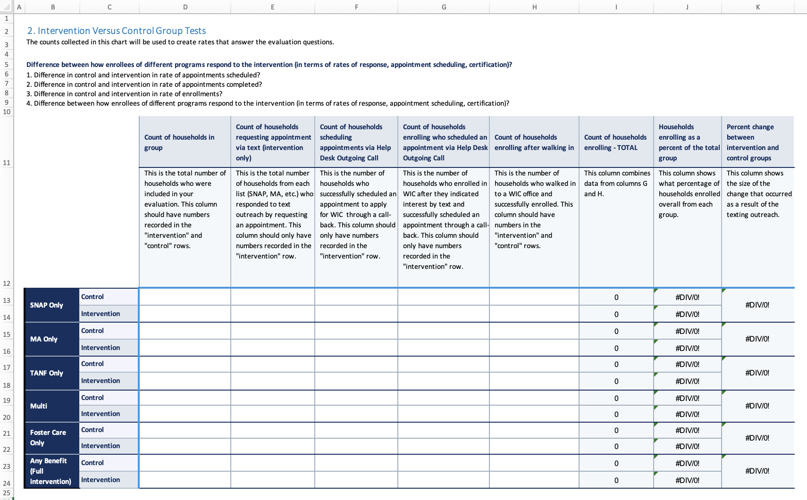

In this spreadsheet, you can see examples of the categories of data you might want to analyze. Here, we are comparing a few groups, and within those groups, distinguishing between those who received text messages prompting them to request assistance applying for WIC and those in the control group, who did not. The groups are based on participation in different benefit programs. By comparing results within each group, we can determine if the intervention caused more potential WIC recipients to enroll than otherwise would have; by comparing across groups, we can determine if enrollees in some programs were more likely to enroll in WIC than enrollees in others.

Example numbers have been entered in the version below so you can see how totals are generated and the percent increase is calculated. In this example, the intervention resulted in small increases in benefit enrollment from several lists, but the list of SNAP participants didn't yield an increase in the intervention group. For TANF participants, those receiving multiple benefits, and those only in foster care, the percent increase between control and intervention groups is very high, but this should be interpreted with caution as those lists are much smaller and the very small sample size is skewing the results.

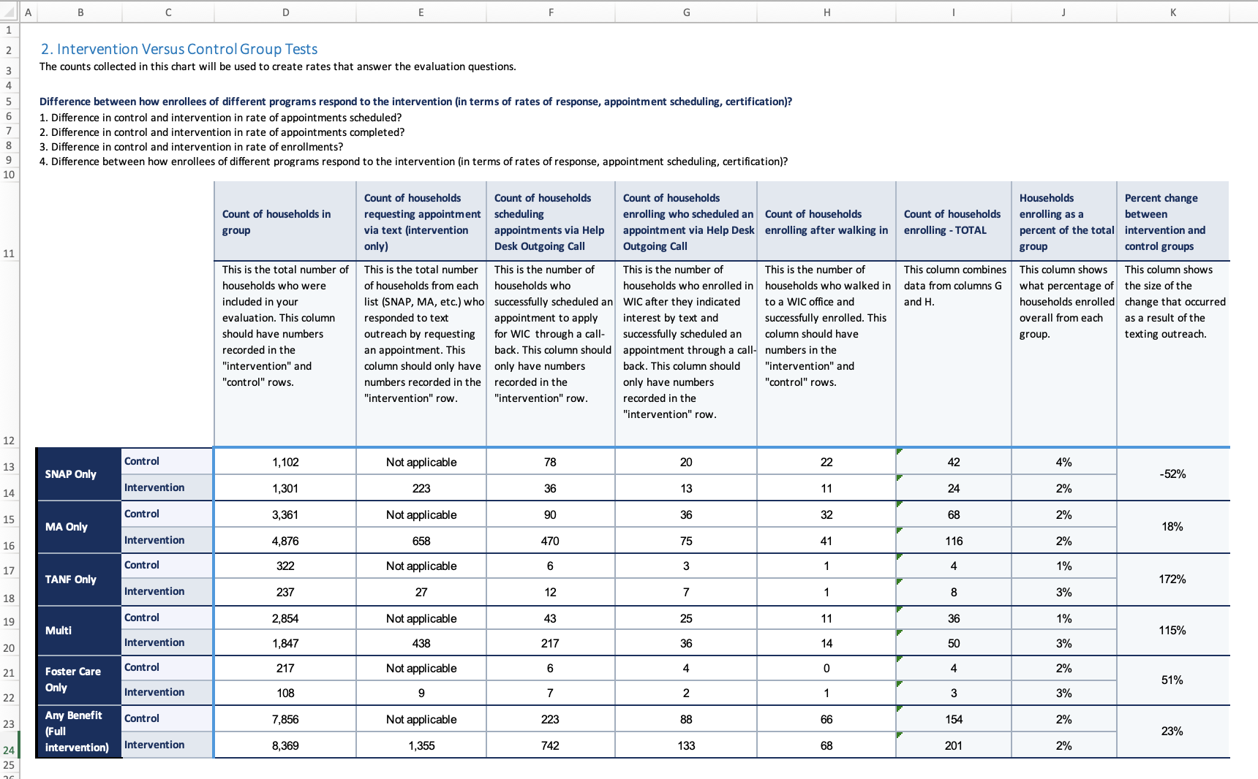

**5. Share Your Findings**

The intended use of your findings that you identified in Tool 10 will shape your dissemination plan. Your team could use the findings to tweak or change your outreach strategies, or the findings might be shared with policy officials, funders, or other states.

Use the space below to identify audiences with whom you will share your findings and any dates by which you will need to do so. For example, you could include the due date for a report to a funder or the date of a meeting at which you plan to share your results. You can always revisit your dissemination plan as your project is implemented.

|  |  |  |  |
| --- | --- | --- | --- |
| **Audience** | **Format**  (such as blog post, slide deck, report, etc.) | **Reason for Dissemination** | **Target Date** |
|  |  |  |  |
|  |  |  |  |
|  |  |  |  |
|  |  |  |  |
| *Add rows as needed…* |  |  |  |

**6. Outstanding Questions**

After all this work, you may have some unanswered questions or areas where you may need more information. Ask your team: what information do you need in order to successfully proceed with this project? Use the space below to keep track.

***Example:*** *Does our data sharing agreement allow us to acquire individual-level data?*

|  |
| --- |
|  |